Excel-lent Preparations
Do you recall one of the standard definitions of GIS – Digital Mapping with Data Management? This presentation is all about data management in Excel. We will look at efficient ways to clean up and organize U.S. Census data. We will explore formula expressions. We will build pivot tables to summarize data. We will dabble with arrays (a formula that can perform multiple calculations on one or more items). In this session, we will share ideas and techniques to save time and ensure accuracy.
US Census Bureau Data
Establish an Excel workbook for a project. Often you will need to download several data tables. These download as .csv files. Rather than trying to save them all separately as Excel tables, I simply copy and paste the data into my Excel workbook and rename the worksheet. In ArcMap, you add worksheets as your tables.
Example:
aff_download folder: ACS17_5YR_B02010_AIAN.csv
saved & cleaned up in CPN_BlockGroup_Data / CPN_BG_AIAN$
Copy & Paste / Replace things that ArcMap doesn’t like. Replace (Crtl-H) / Rename columns /
Delete second row / Assign Data Type to columns
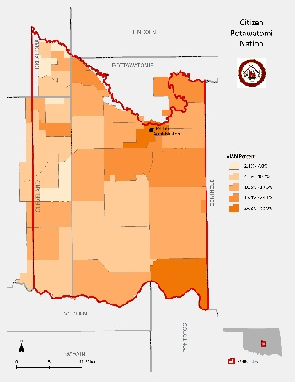
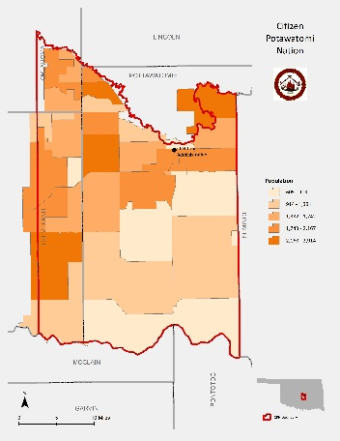

Pivot Tables
Insert Pivot Table
Arrays
In Excel, an Array Formula allows you to do powerful calculations on one or more value sets. The result may fit in a single cell or it may be an array. An array is just a list or range of values, but an Array Formula is a special type of formula that must be entered by pressing Ctrl+Shift+Enter.

